

Republic Services

GH#265 – VCD for Removal Fee on Customer Owned Container Decrease Service

Julie Felberg | February 20, 2015

|  |  |  |  |
| --- | --- | --- | --- |
| Category | Documents | Sub Category | Documents - Doc Engine |
| Use Case |  | Test Case |  |
| LOE |  | Go Live Date |  |

# Business Reason

A1469528 [2177314048] PROD

Existing customer, customer owned containers, reduce service from 4 to 2. While removal is not charged, the CSA shows a Valued Customer Discount - which is incorrect.

## The VCD comment should not be replaced, it should be removed. Also, please make sure the REM (Removal) of $0 for this particular scenario.

# Task Requirements

1. For A1469528, the “Valued Customer Discount” (VCD) should not be displayed.
2. For A1469528, the REM should be $0

# Build Plan

Investigation

1. Why is the VCD showing up on the quote? (The VCD is stored in the deliveryAndExchangeCreditStringForOutput_quote attribute)

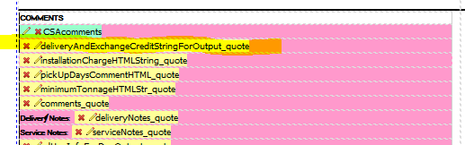

1. The attribute is set in the commentsForDeliveryAndExchangeCreditOnOutput commerce library.
2. Attribute is set on line 134 (in dev) for this case and line 75 in Prod.



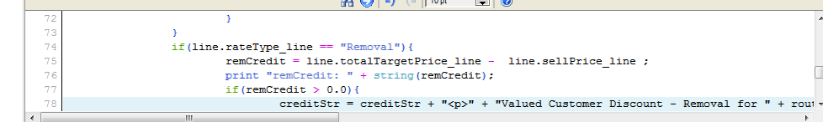

1. This line is added if remCredit > 0.0 AND line.rateType_line == "Removal" AND line._model_name == ""
2. In Dev: remCredit = (line.totalTargetPrice_line - line.sellPrice_line) * line._price_quantity in dev
   1. In Prod: remCredit = line.totalTargetPrice_line - line.sellPrice_line
   2. In our case (prod):
      1. remCredit = 190.0

# Implementation Profile Changes

# User Guide Changes